Att. 2

Minutes of the 2. European Coordination Meeting
Online Conference – 25th Jule, 2020

ECI Start Unconditional Basic Incomes throughout the EU
Participants: AT: Helmo Pape, Klaus Sambor, Ulrike Sambor
BG: Karilov Ivaylo, Violeta Petrova
DE: Ronald Blaschke, Werner Rätz, Helwig Fenner
Estonia: Jaanus Numoja
Finland: Juha Uski
FR: Reihere Maruhi
HU: Evamaria-Langer-Dombrady, Zita Stockwell-Szabadka, Marta Szutor,
Andras Lazar
IT: Michele Gianella
NL: Willem Gielingh, Robin Ketelaars
Portugal: Catarina Neves
Spain: Leo Del Prado, Mayte Quintanilla, Pachi Alvarez
Turkey: Ali Mutlu Köylüoglu

Excused: Michaela Kerstan (DE), Narcy Calamatta (Malta), Alexander Stredak (SK),
Angel Bravo (Spain), Heinz Swoboda (AT)

Moderator: Klaus Sambor
Minutes: (collected parts and summarized) by Klaus Sambor)

13:15
Report of the Coordination Team meetings since our first ECM
P: Klaus Sambor / Ronald Blaschke

Klaus Sambor mentioned, that the Coordination Team had each week an Online Conference, to which also National Coordinators and Substitutes had been invited as guests. The reports of each meeting was always distributed to the all national Coordinators and Substitutes.
One important point is, that the Coordination Team has written a Letter to the UBIE Board, but has not received an answer yet. This item will be discussed in the next Coordination team (29.07.2020).
In addition the central online collection system shall allow the uploading of statements of support also collected in paper form. Clarification of „Handling“ and responsibility of the organizer-group (Citizens Committee) was mentioned. We want to make clear, that every national Coordinator and Substitute of our ECI should invite the activists in his country to collect signatures not only online, but also in paper form. The collected paper forms have to be sent to the national Coordinators by certified mail, only to the address, which they will give to their activists.
Example for AUSTRIA: postal address is: Postfach 21, 2345 Brunn, EBI-BGE-AT
(Box number xx, ECI-UBI-Country code)
The signed paper forms must be kept in a safe place.
At least two months after the end of the collection time, all in paper form collected signatures should be uploaded and the Commission should be informed about this. The concrete procedure will be announced later, after this is clarified with the Commission and the tests have been performed.
The work of the ECI Team is very much progressed and will continue in full speed.

13:45
EU-Level Webpage
- Our registered ECI:
http://ec.europa.eu/citizens-initiative/public/initiatives/open/details/2020/000003
- Tests with the OCS of EU

Klaus Sambor presented at first 2 figures from Heinz Swoboda

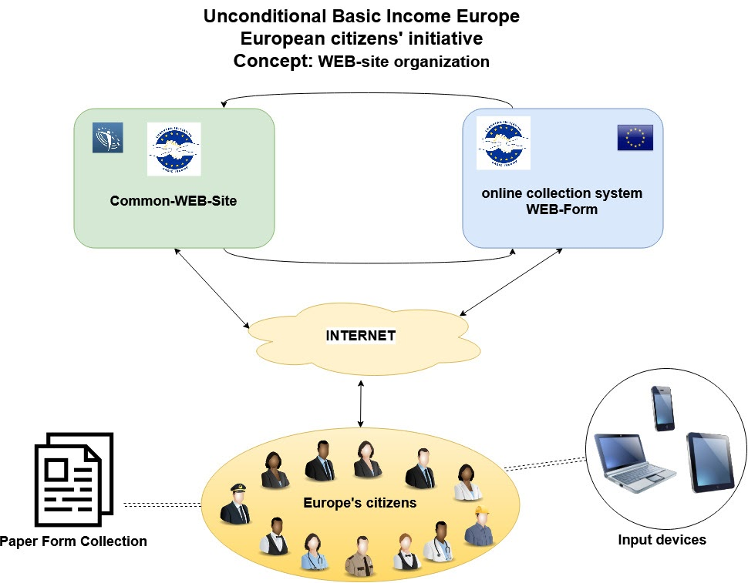

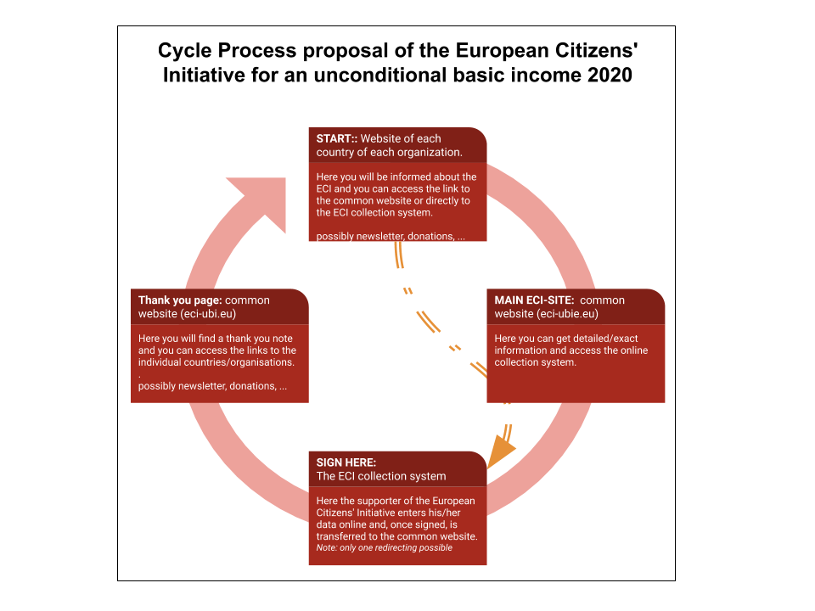

In our first ECM on 20.06.2020 it was mentioned, that we have already decided in the ECI-meeting in Berlin (24.03.2019) to use the OCS system of the EU.
In the following Coordination Team (24.06.2020) after the ECM this was confirmed and tests have been already started and will go on, because it is necessary to get everything tested before the starting date 25.09.2020.
The OCS-System allowed also to send information ito the signatories (in their own language). So we can spread and advance the EU-wide campaign for a succesful ECI UBI.
Mainly, there will be a common page for all countries. It would be good, if only the IT-responsible persons of the national Campaigns contact Heinz Swoboda. He has got quick answeres from the EU-IT department to his questions.
Heinz Swoboda will send an E-mail to collect all information on connecting the national websites and the logos of the different associations that take part in the ECI to put them on the website within the next weeks.
However because his mother died just now, he will only be available from 03.08.2020. If you have any question about connection of how to connect your own national website to our OCS, please contact (ECI-UBI-IT) Heinz Swoboda (hs@pro-grundeinkommen.at). We keep working!

- The actual state you can find on the LINK https://eci-ubi.eu
https://eci-ubi.eu/thankyou/

Robin Ketelaars presented the LINKS which are given above ("Starten Sie bedingungsloses Grundeinkommen in der gesamten EU" and Thank you for your signature)

Robin Ketelaars
team@ubi4all.eu
you can use for questions

14:45
Break

15:15
National Campaign plans:

The following plans were presented and intensive discussed.
Statement from beginning July 2020: „This should be done, because the other National Coordinators can perhaps find some idea, which you want to do, also useful for their campaign.
We from the ECI-UBI Coordination Team will not make decisions for you, because you will be the best informed, what could be useful in your country to collect signatures.“

Spain ( presented by Mayte Quintanilla) see Att. A, see also the LINK below:
https://youtu.be/WFUgsvsxtfk UBI, our right to live (Mayte Quintanilla- Spain : If someone wants to make subtitles in his/her idiom, just let me know)
HU (presented by Evamaria Langer-Dombrady and Zita Stockwell -Szabadka) see Att. B
(presented by Andras Lazar) see Att. C
Finland (presented by Juha Uski) see Att. D
NL (presented by Willem and Robin Ketelaars) see Att. E
AT (presented by Helmo Pape) see Att. F
DE (presented by Werner Rätz) see Att. G
Portugal (presented by Catarina Neves) see Att. H
Turkey (presented by Ali Mutlu Köylüoglu) see Att. I
BG (presented by Karilov Ivaylo) see Att. J
Estonia (presented by Jaanus Numoja) see Att. K, see also the LINK below:
https://drive.google.com/file/d/1CyUwNsGdtGvrKe-Z5Kx15XAmunNx5vgJ/view?usp=sharing
IT (presented by Michele Gianella) see Att. L, see also the LINK below:
https://www.youtube.com/watch?v=lqXXO0GGNRI
FR (presented by Reihere Maruhi) see Att. M

16:45
Break

17:00
Fundraising

Report of the Raffle-ad-hoc Group: Ronald Blaschke, Klaus Sambor, Helwig Fenner, “Mein Grundeinkommen”

Helwig Fenner presented the „European UBI Raffle“ (CONCEPT FOR THE EUROPEAN CITIZENS‘ INITIATIVE FOR AN UNCONDITIONAL BASIC INCOME 2020/2021) see Att. N

After an intensive discussion the concept was clarified. The participants of the 2. ECM have all agreed to the proposed European raffle principle. Catarina Neves (from Portugal) will work further on in the Ad-hoc Group. Her engagement was very wellcomed.

Helwig Fenner wrote:

„Dear National Coordinators,

the time is running... we all want to run a successful ECI.
If we want to use the raffle of a European Basic Income properly for getting millions of signings we should use the next 3 months to implement it.

Helwig from Mein Grundeinkommen offers his support to build up the raffle system. Sure, there are a few requirements...
- build up a catchy website incl. donation pay system, registration form for the raffle and serious content
- donations distribution
- organizing a raffle
but in all it's not rocket science and easy to handle by a team of 2-5 activists.

So, I'd like to ask you if you/your NGO could imagine to be the responsible institution for this concept – whether for a European Basic Income or for a national Basic Income in your country. Please respond to me: Would you like to implement the raffle of UBI in your country?

If you want to know which legal questions are needed to be clarified, which functions the website need, or how to distribute the donations, please do not hesitate to contact Helwig
+49 176 55704563
helwig@mein-grundeinkommen.de

17:30
Campaign events on EU-level

a) central common events
Juha Uski from Finland presented the following paper:
EU-wide ideas

Campaign launch ideas “Video sample from signing people” and “Logos at famous buildings in several European capitals” are good. We should research the possibility of projecting the logos. Permission is needed. The signing should happen in front of the projection, so it makes a nice video and the videos from the different countries should be edited together immediately so they can be sent to the media at once. The atmosphere of this mediatic event should be: “people in action”.

At the same time there needs to be somewhere a pan-european press conference. Basicly it could happen in virtual space, for the international medias, and it would be great if we can have quick samples of videos of the action of the same day, directly in the press conference. For example, the action at midday, and press conference at 2 pm. I think it would be interesting to reach this but everyone needs to count on an able tech team (of min 2 persons who can manage to make and send the video quickly) and someone who centrally composes an unified video.

A professional level press release. Count me in for the spelling check and editing!

Internationally, perhaps the campaign needs its own Youtube channel, where all videos from different countries can go.

Internationally, sharing the information about how many followers there are in the social media channels?

A common databank of memes. All kinds, but important to save them in a format where the text and the graphic are on separate layers so that the same meme can easily be translated and used in another country. In the same folder a file, where all the texts of the memes are in original language and an English translation.

In making memes, we can also make a European team, since some of the memes are easily shareable between countries, if their content is generally understandable and funny, not relying on local references and atmospheres. Humour is a central element in memes, also positivity and surprise. We have a common picture and the text can be translated to the other country’s language. We have an idea, someone else in another country knows an artist that would like to draw that idea, shared as a creative common.

In Finland, we’re aiming at a “weekly meme” campaign (as mentioned in the national plan) but they could be even more.

Also videos can be subtitled and shared, but it is more work and less people who see the entire video. Short videos could work much better than long. I mean, Really short. Other are the more serious works like the documentary “UBI, Our Right to Live”; but in between is not that useful. Really short, or then a thorough one, but here in campaign the really short videos are the best (maximum two minutes, I think).

Each country could think of a goal every month for various kinds of publications and outreach (how many people we want our message to reach, and how many signatures that could result in).

Other comments:

It is important to create the sensation to each person that their signature or participation or help in the campaign is important and makes a difference!

Remember that in the social media, also negative replies to our posts add to the visibility of the campaign! Therefore, while it is good to reply in a positive way to negative comments, one can be thankful for each and any comment!

Also, the medias are interested in Drama. Not boring stuff, has no followers. How to make a positive media drama? A “buzz”. Not an objective in itself, but remaining alert to possibilities. With memes one can relate to current affairs with humor; that is positive drama. Important to keep the positivity of the theme and raise it.

b) milestones at EU level
Will be discussed at the 3. ECM.

18:00
Next steps

It was decided, to organize a 3. ECM during August 2020. For that a doodle was established and this doodle should be filled in until 29.07.2020 16:00:
Doodle to vote: https://doodle.com/poll/qkb28cnqd5vecii8
At the Coordination Team 29.07.2020 the date for the 3. ECM will be decided.

Klaus Sambor thanked all participants for the lively discussion and thanked also our friends of Spain that we could use their ZOOM online conference tool again.

P. S.: These minutes are not meant to give everybody’s speech and exact wordings, although it has been recorded by Leo Del Prado (the files [2,35 GB] are available for download until 1st Aug. 2020). Thank you Leo very much!

18:00
End of the meeting

