Success of the ECI for UBI – we believe in it! (Att. 7)
For the European Citizens´ Initiative (ECI) “Unconditional Basic Incomes (UBI) throughout the EU” we have good news: The EU Commission has prolonged the time period for the collection of signatures for our ECI by 3 months, that means until 25th Dec. 2021 (https://europa.eu/citizens-initiative/_en)
The reason for this is given by the Corona-19-situation, when it is complicated to get in touch with people to make them aware of our ECI. This European Citizens´ Initiative for Unconditional Basic Incomes is the only official EU-petition for UBI. It claimes particular legal measures by law – if the ECI is successful.

Another good news is: We have reached the first 100.000 signatures for our ECI. With your help we now aim 1 million signatures for our petition. Please everyone share the link to your family, friends, colleagues. Together we can bring UBI to Europe – directly to both, the EU Parliament and the EU Commission!

Further information on this website https://eci-ubi.eu,
on facebook https://www.facebook.com/ECIUBI and twitter https://twitter.com/EciUbi.

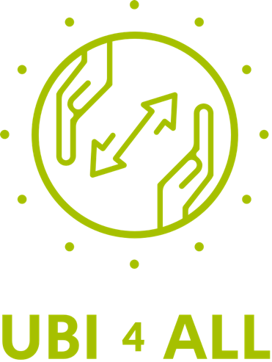

Good news also from UBI4ALL: Almost 7 months of one Basic Income for one year (€800 per month) are raised now. UBI4ALL will raffle it off randomly to their community throughout the European Union. Every EU resident is eligible to participate which is free on the website www.UBI4ALL.eu – offered in 18 languages. Support the UBI4ALL crowdfunding in order to let people experience UBI in real life. The news that you can win Basic Income for one year is expected to attract many signatures for the UBI petition and to get some media interest by the way.

We wish you all best!

Klaus Sambor, Österreich
Ronald Blaschke, Deutschland

